Computer Organization and Assembly Language

*Name:*

*Waleed Akram*

*Roll no.*

*20P-0640*

*Section:*

*3-B*

*Batch:*

*Fall 2020*

*Lab:*

*# 03*

*Lab Instructor:*

*Dr. Usman Abbasi*

*FAST NUCES Peshawar Campus*

Lab Task: Write a program in assembly language that calculates the square of six by adding six to the accumulator six times.

Code: [ .asm file ]

[org 0x0100]

mov ax,0 ; move 0 to accumolator registor ( ax )to avoid garbage value

mov cx,0; move 0 to counter registor ( cx ) to avoid garbage value

mov cx,6; move 6 to counter registor ( cx )

outerloop:

add ax,6 add 6 into already value into accumolator register ( ax )

sub cx,1 ; subtact1 from counter register value (6)

jnz outerloop ; condition

mov ax, 0x4c00 ; for exit

int 0x21 ; intruption

[ .lst file ]

     1                                 [org 0x0100]

     2

     3 00000000 B80000        mov ax,0       ; move 0 to accumolator registor ( ax )to avoid garbage value

     4 00000003 B90000        mov cx,0   ; move 0 to counter registor ( cx ) to avoid garbage value

     5 00000006 B90600        mov cx,6             ; move 6 to counter registor ( cx )

     6

     7                        outerloop:

     8 00000009 050600            add ax,6       ; add 6 into already value into accumolator register ( ax )

     9

    10 0000000C 81E90100         sub cx,1             ; subtact  1 from counter register value (6)

    11 00000010 75F7            jnz outerloop       ; condition

    12

    13 00000012 B8004C            mov  ax, 0x4c00     ; for exit

    14 00000015 CD21              int  0x21           ; intruption

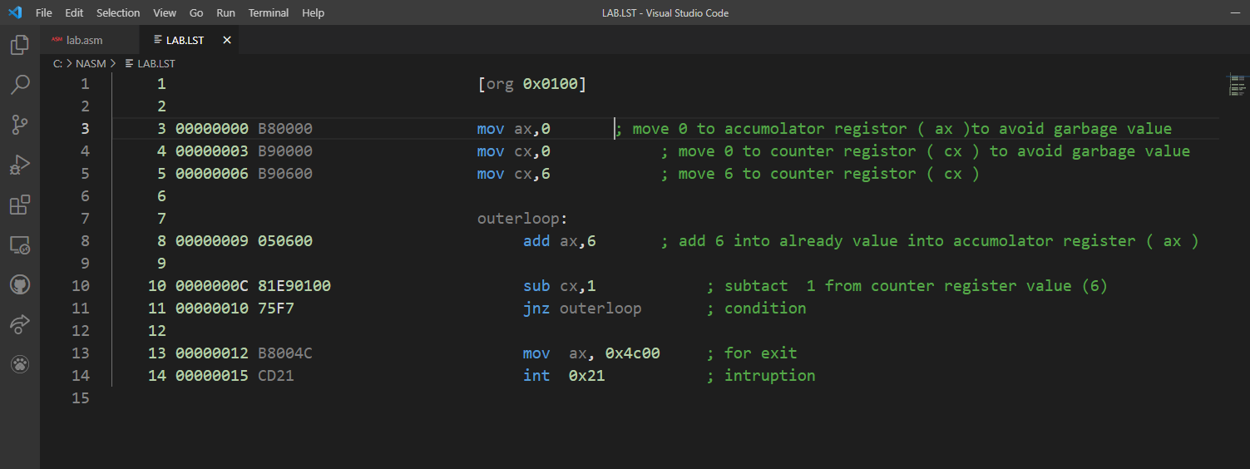

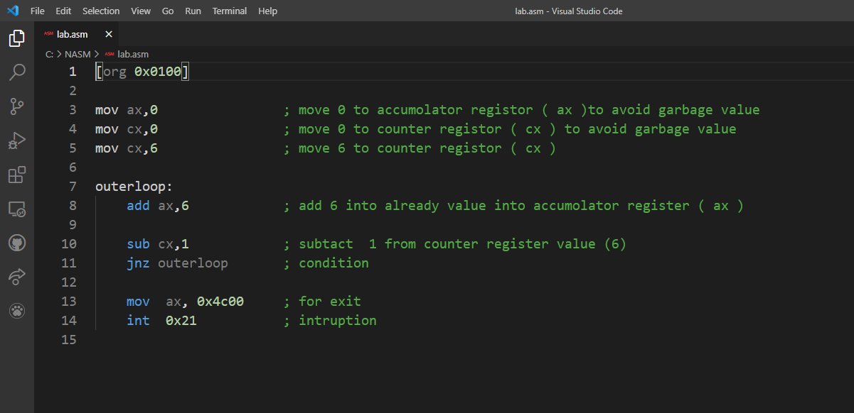

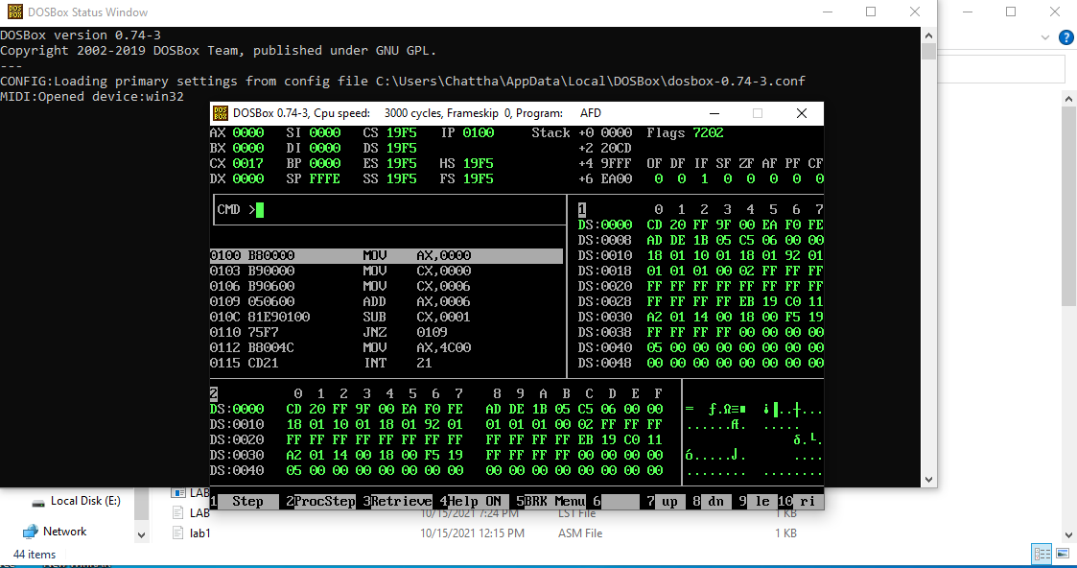

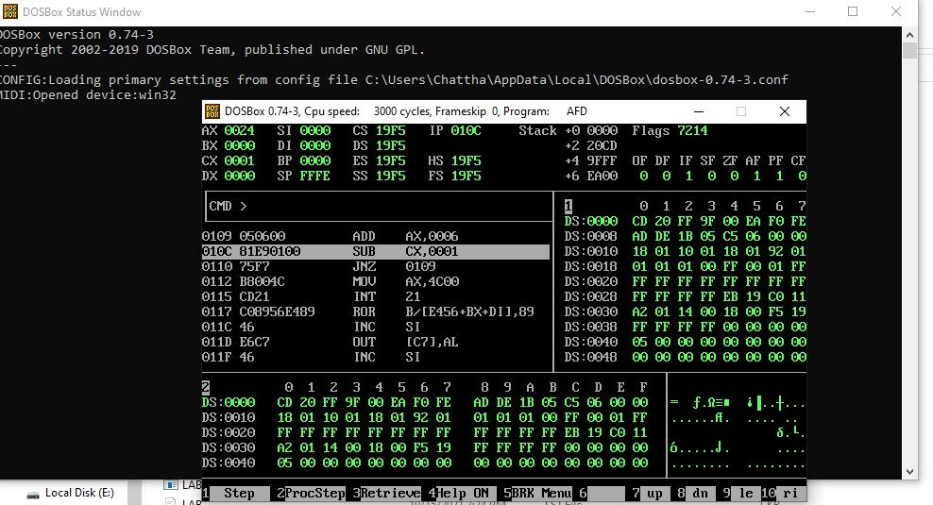

**COMPLETED**